MR Analysis

Assumption Checks #2 and #3: Homoscedasticity and Independence of the error terms

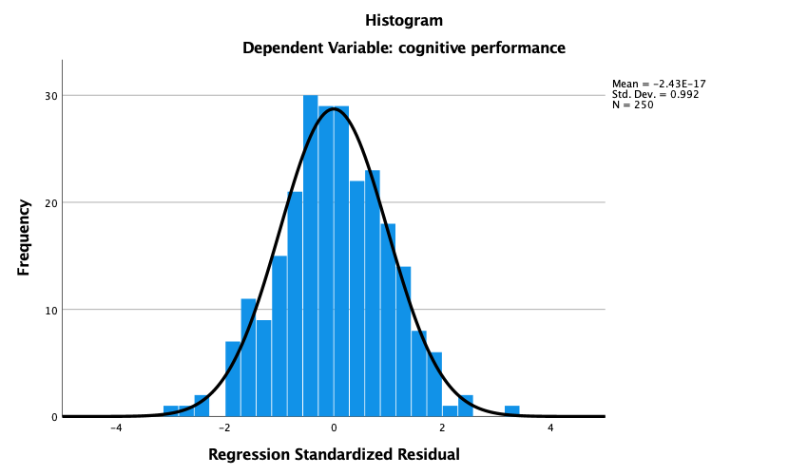
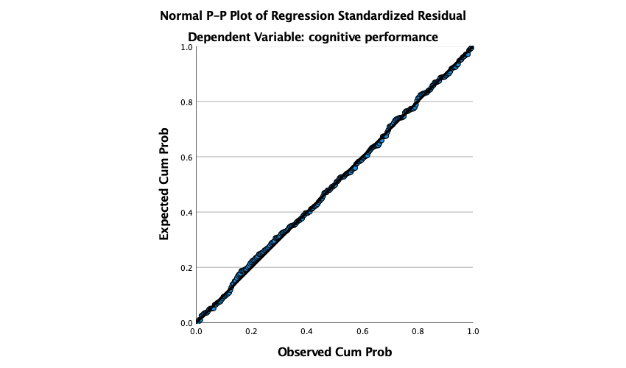
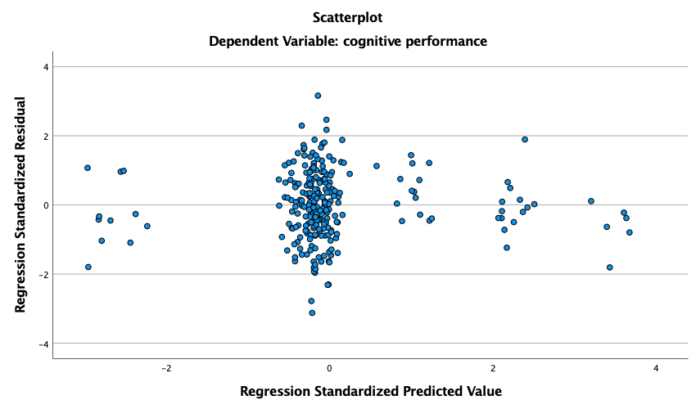

Model Summary^{b}
Model | R | R Square | Adjusted R Square | Std. Error of the Estimate | Durbin-Watson
1 | .555ª | .308 | .297 | .83850981 | 2.015
a. Predictors: (Constant), education in years, stress sensitivity, sociability, reaction to adrenaline
b. Dependent Variable: cognitive performance

Coefficientsª
Model |  | Unstandardized Coefficients |  | Standardized Coefficients | t | Sig. | Collinearity Statistics
 |  | B | Std. Error | Beta | t | Sig. | Tolerance | VIF
1 | (Constant) | -4.056 | .415 |  | -9.782 | .000
1 | sociability | .075 | .053 | .075 | 1.416 | .158 | .994 | 1.006
1 | reaction to adrenaline | -.060 | .054 | -.060 | -1.118 | .265 | .979 | 1.022
1 | stress sensitivity | -.005 | .053 | -.005 | -.091 | .928 | .997 | 1.003
1 | education in years | .330 | .033 | .532 | 9.863 | .000 | .970 | 1.031
a. Dependent Variable: cognitive performance

Appendix

Assumption Check #1: Linearity
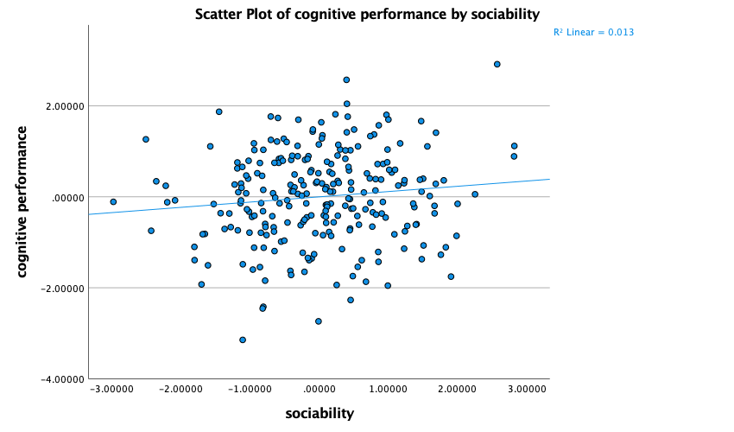
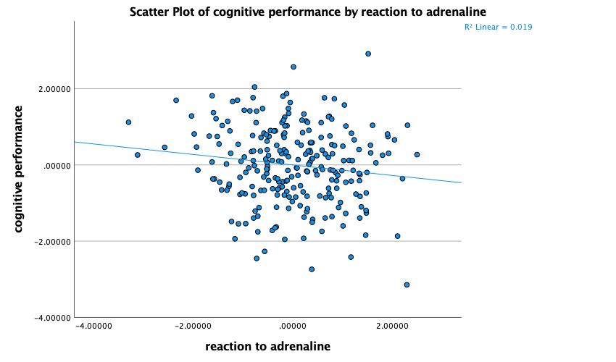
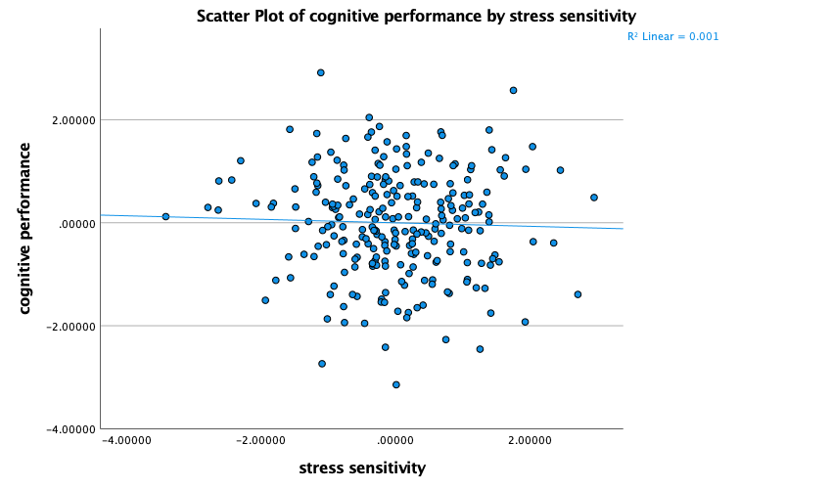
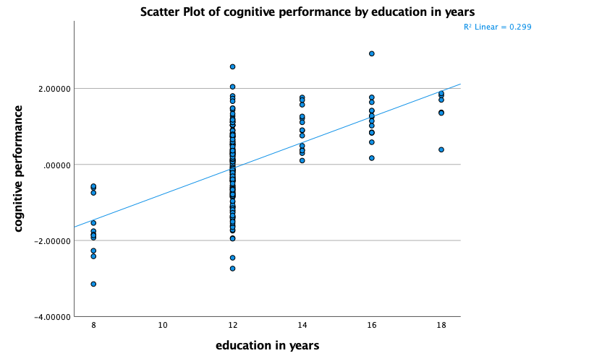
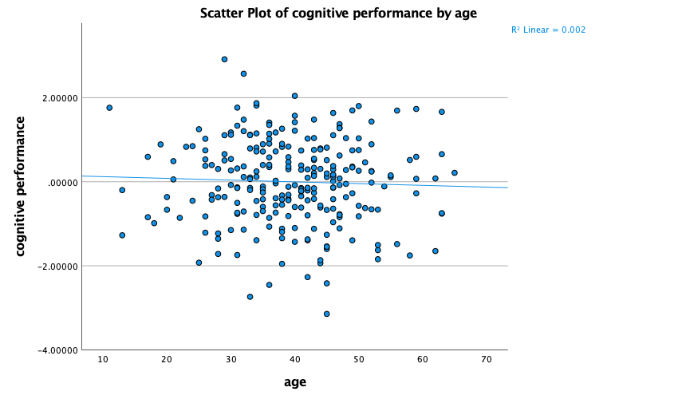
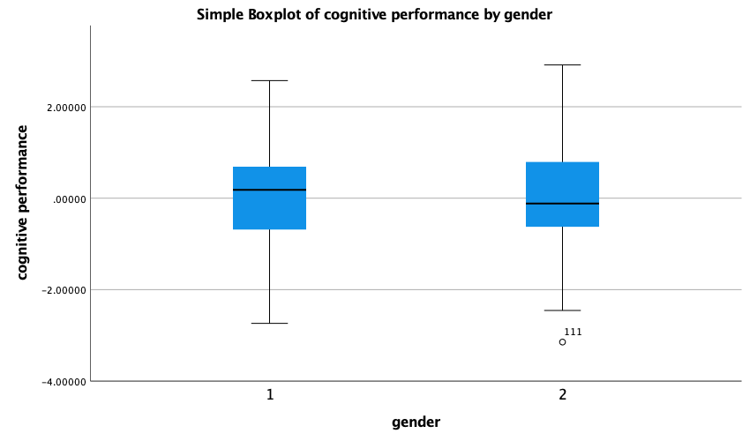

Assumption Check #4: Normal distribution of the dependent variable
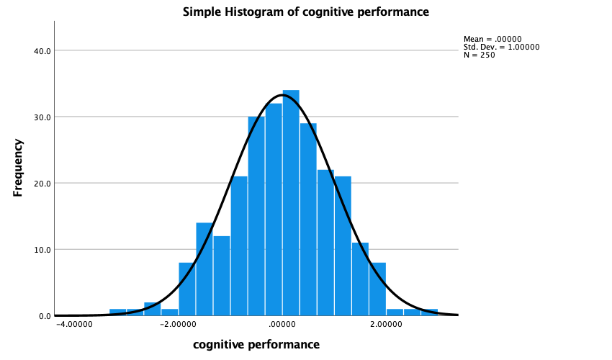

Correlation matrix of the 6 independent variables and dependent variable

Correlations
Pearson Correlation
 | cognitive performance | sociability | reaction to adrenaline | stress sensitivity | education in years | gender | age
cognitive performance | 1 | .116 | -.138* | -.034 | .547** | -.026 | -.042
sociability | .116 | 1 | .000 | .000 | .076 | .120 | -.192**
reaction to adrenaline | -.138* | .000 | 1 | .000 | -.146* | .038 | -.194**
stress sensitivity | -.034 | .000 | .000 | 1 | -.055 | .110 | .033
education in years | .547** | .076 | -.146* | -.055 | 1 | .034 | -.145*
gender | -.026 | .120 | .038 | .110 | .034 | 1 | .034
age | -.042 | -.192** | -.194** | .033 | -.145* | .034 | 1
*. Correlation is significant at the 0.05 level (2-tailed).
**. Correlation is significant at the 0.01 level (2-tailed).

